By Ed Siegel

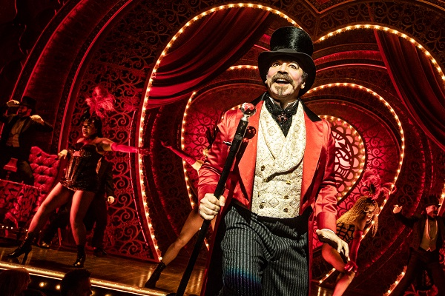
Danny Burstein as Harold Zidler in “Moulin Rouge! The Musical”

“Moulin Rouge” marks both the triumphant return of the Colonial Theatre to the Boston arts scene and the triumphant ascent of its new stewards, the Ambassador Theatre Group, the architects of the superb job of restoring the theater to its former glory.

“Moulin Rouge,” formally “Moulin Rouge! The Musical,” fits the Colonial, formally the Emerson Colonial Theatre, like a glove. The Colonial’s quiet opulence frames the action of the boisterous opulence of John Logan’s adaptation of the Baz Luhrmann’s film like proud parents hosting their teenage kids’ graduation party.

And what a party it is. Part “Cabaret,” part “Rent” and part French can-can, it’s a celebration of la vie boheme with the hyper-imaginative director Alex Timbers, athletic choreographer Sonya Tayeh and the spectacular set designer Derek McLane acting as ringmasters for a first-rate cast. Karen Olivo in the Nicole Kidman part of Satine makes me wish I had seen “In the Heights” (Vanessa) and the “West Side Story” revival (Anita) on Broadway. I did see Aaron Tveit as Bobby in “Company” at Barrington Stage Company last year and it’s fun to see him continue to thrive. And anyone who saw Sahr Ngaujah as “Fela” at ArtsEmerson or in New York knows what a charismatic performer he is – here he’s Toulouse-Lautrec, no less.

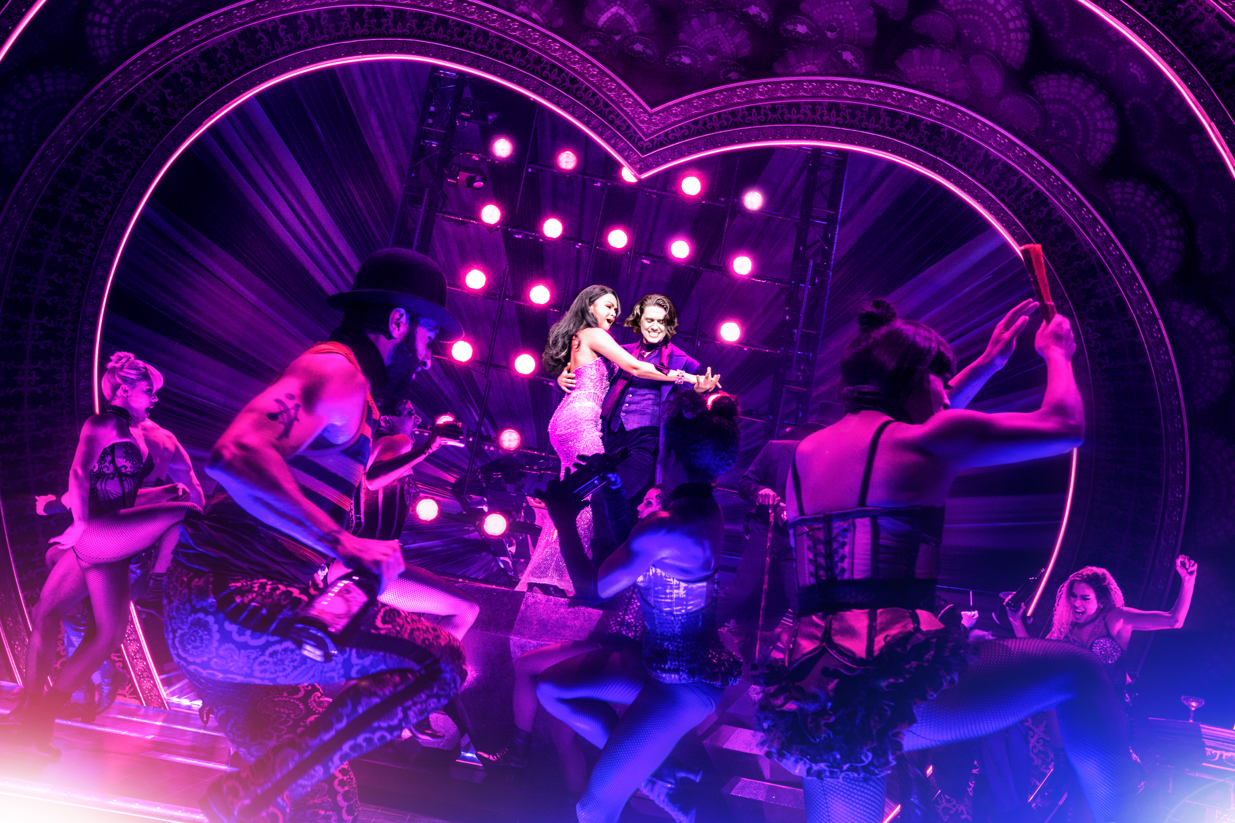
Karen Olivo and Aaron Tveit with company members of “Moulin Rouge! The Musical.” (Photo by Matthew Murphy)

The musical, like the movie, exults in mash-ups of popular songs. Oliva’s entrance is an ode to non-bohemian materialism – “Diamonds are Forever,” “Diamonds Are a Girl’s Best Friend” and “Material Girl.” Tam Mutu as the diabolical duke sings a medley of Rolling Stones songs including “Sympathy for the Devil.”

The songs fit the action, eliciting a steady stream of giggles as the audience recognizes snippets of an “Every Breath You Take” here and an “Everlasting Love” there. But if “Moulin Rouge” underscores the joys of the pop song, it also makes evident its limitations. They’re filled with what author Mark Edmundson calls pop transcendence, which isn’t nearly the same as the real thing you get in a musical masterpiece in any genre.

It doesn’t help that the story itself never escapes the clutches and cliches of 19th Century “Camille” romanticism. Luhrmann got away with it in the movie because of his ironic cinematic style. Logan and Timbers, for all their imagination, take a duller, more realistic approach and their bohemianism, as a result, seems as dangerous as a high-priced Chardonnay.

I also wish Timbers, who directed the immersive masterpiece “Here Lies Love,” had drawn the audience in more. Diane Paulus used the Colonial to much greater effect in that regard in “Hair.” But c’est la vie not so boheme. A work of art? Non. Entertaining? Mais oui.

Ed Siegel is the founding editor and critic at large of WBUR’s The ARTery.jo

